**Conflict in Libya Across Time**

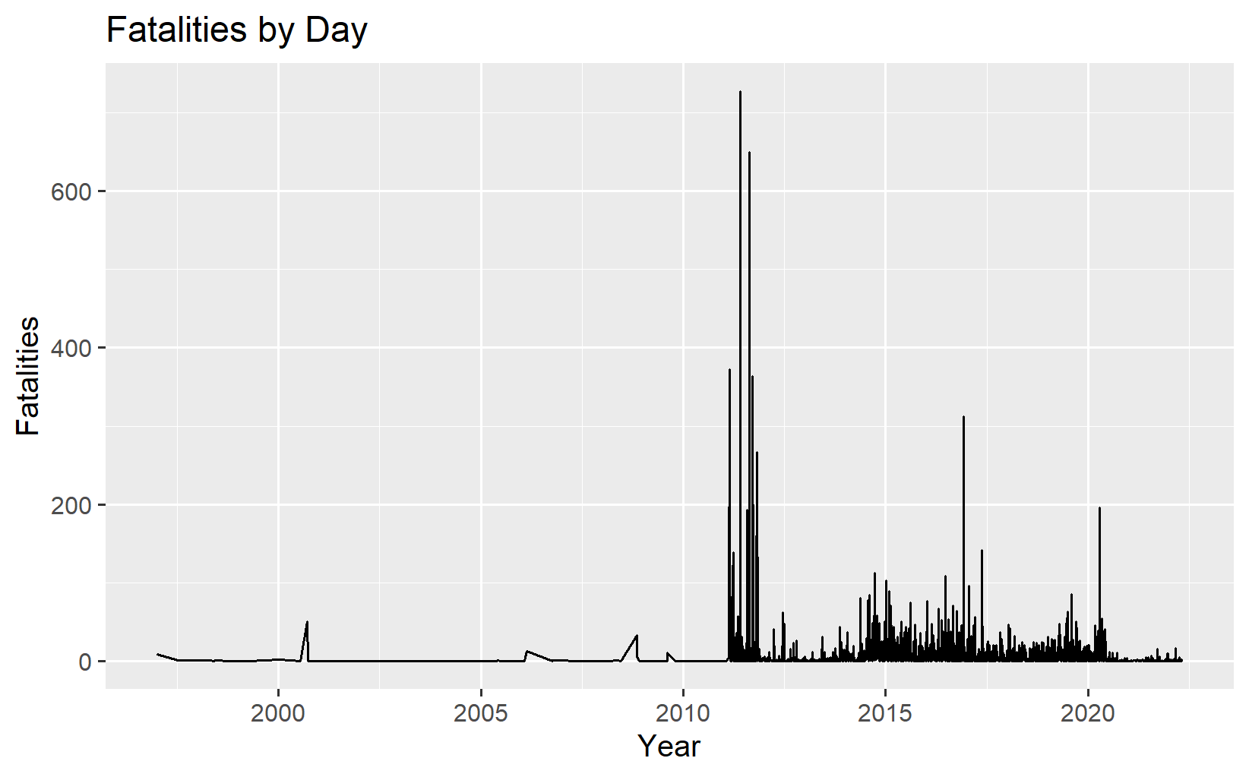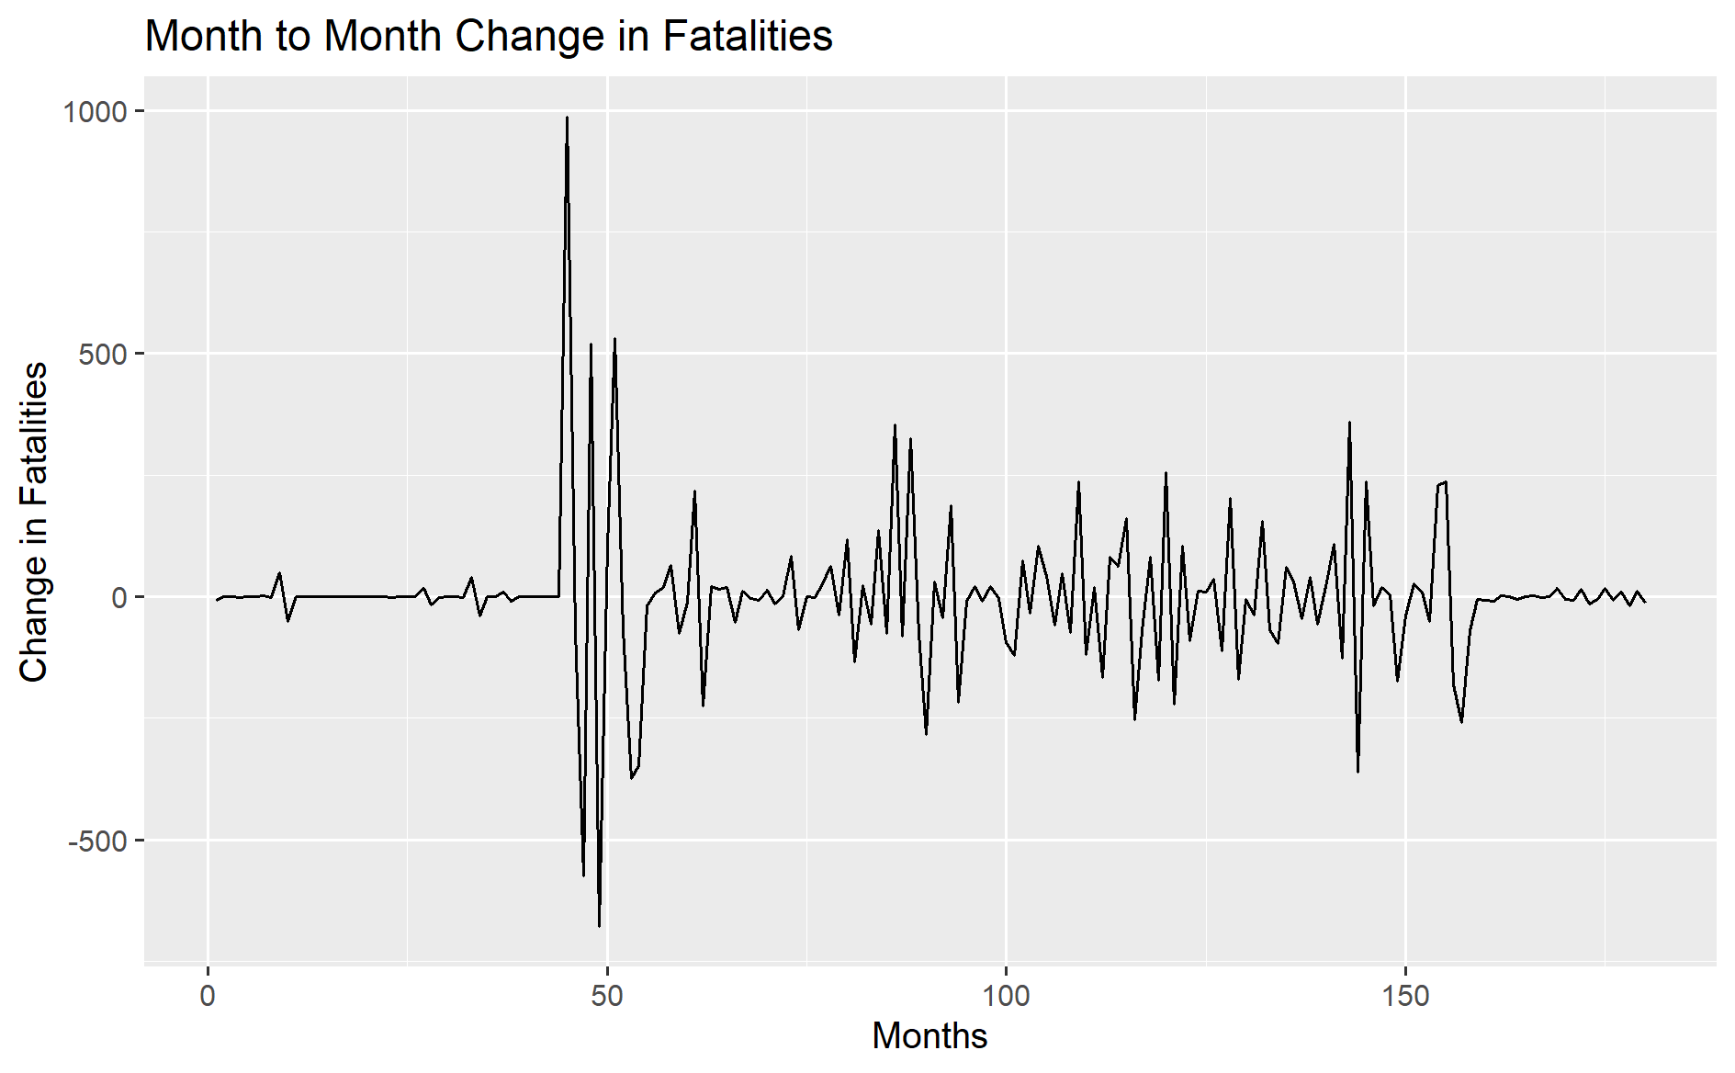

Total Events and Fatalities by Year: 2011-2022

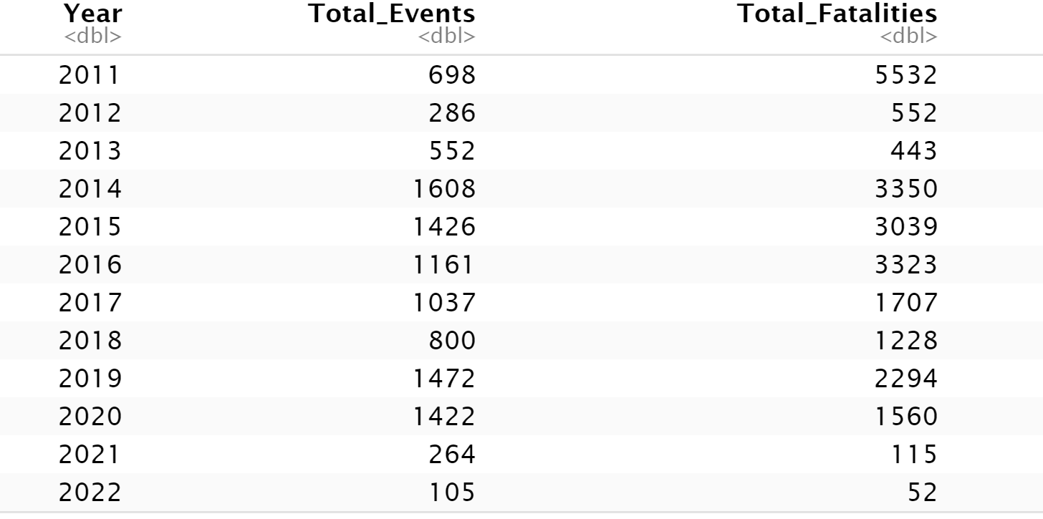

Since the ceasefire agreement of October 2020, the number of conflict related events and fatalities has significantly decreased. Specifically, the yearly percent change in conflict events from 2020 to 2021 decreased by 81.4% and the total number of fatalities is down by 92.63%. Also encouragingly, levels of violence and conflict in 2022 appear to be following those of 2021 rather than the yearly levels of violence seen during the worst of the Second Civil War. Despite this, the reduced levels of conflict are tenuous and there is potential the scenario could change depending on the realization of national elections, which have been delayed since 2021, and the impending results.

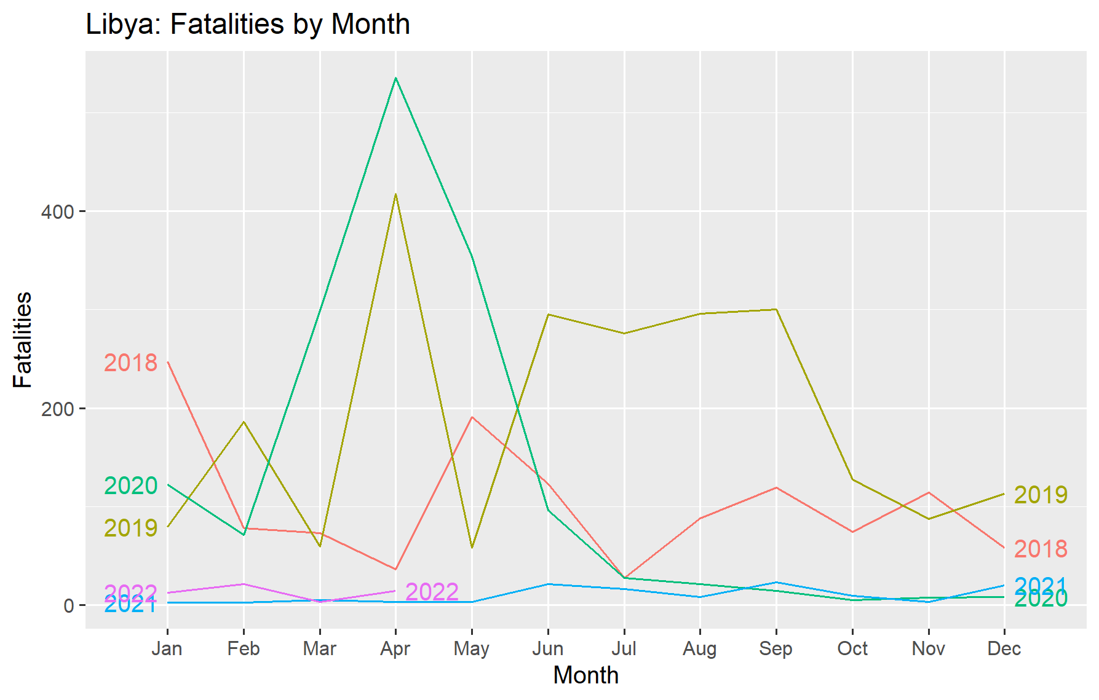

**Analysis of Conflict by Region**

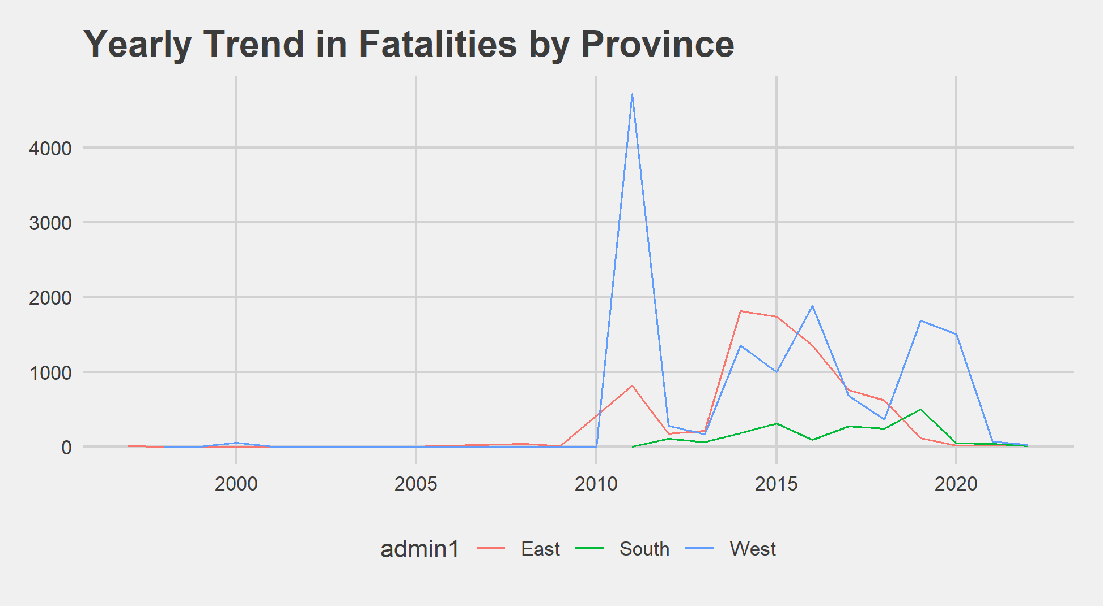 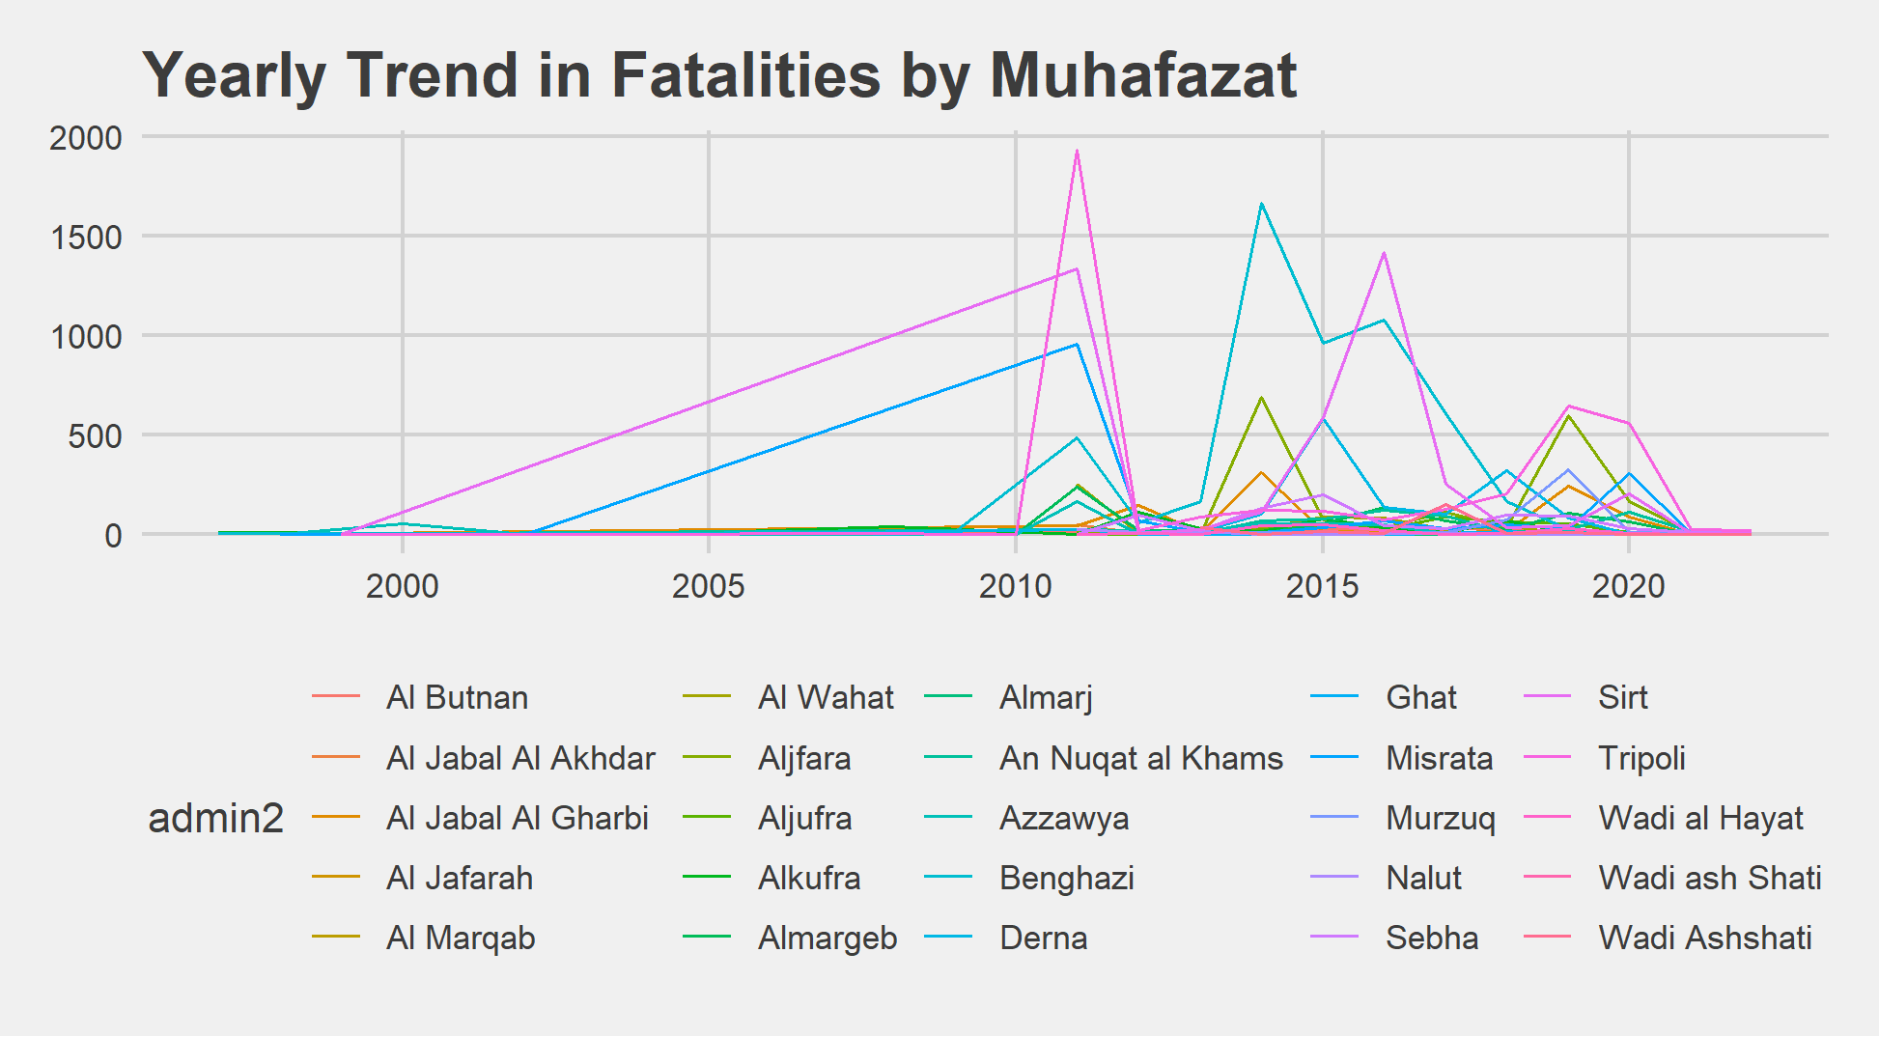

Although conflict has been present through all regions of Libya, the 2014-2019 timeframe saw significant levels of conflict in the East province, whereas in 2019-2020 conflict was concentrated almost entirely in the West province. At the Muhafazat (ADMIN-2) level, over half (56%) of all fatalities recorded in the ACLED database (1997-present) have occurred in three units: Benghazi (22%), Sirt (17%), and Tripoli (17%). Since 2014, the proportion of all fatalities in these three muhafazats has largely stayed the same at 54%, with relative increases in Benghazi (27%) and a decrease in Tripoli (11%).

**Actor Analysis**

Main Actors Involved in Conflict Events, 1997-2022

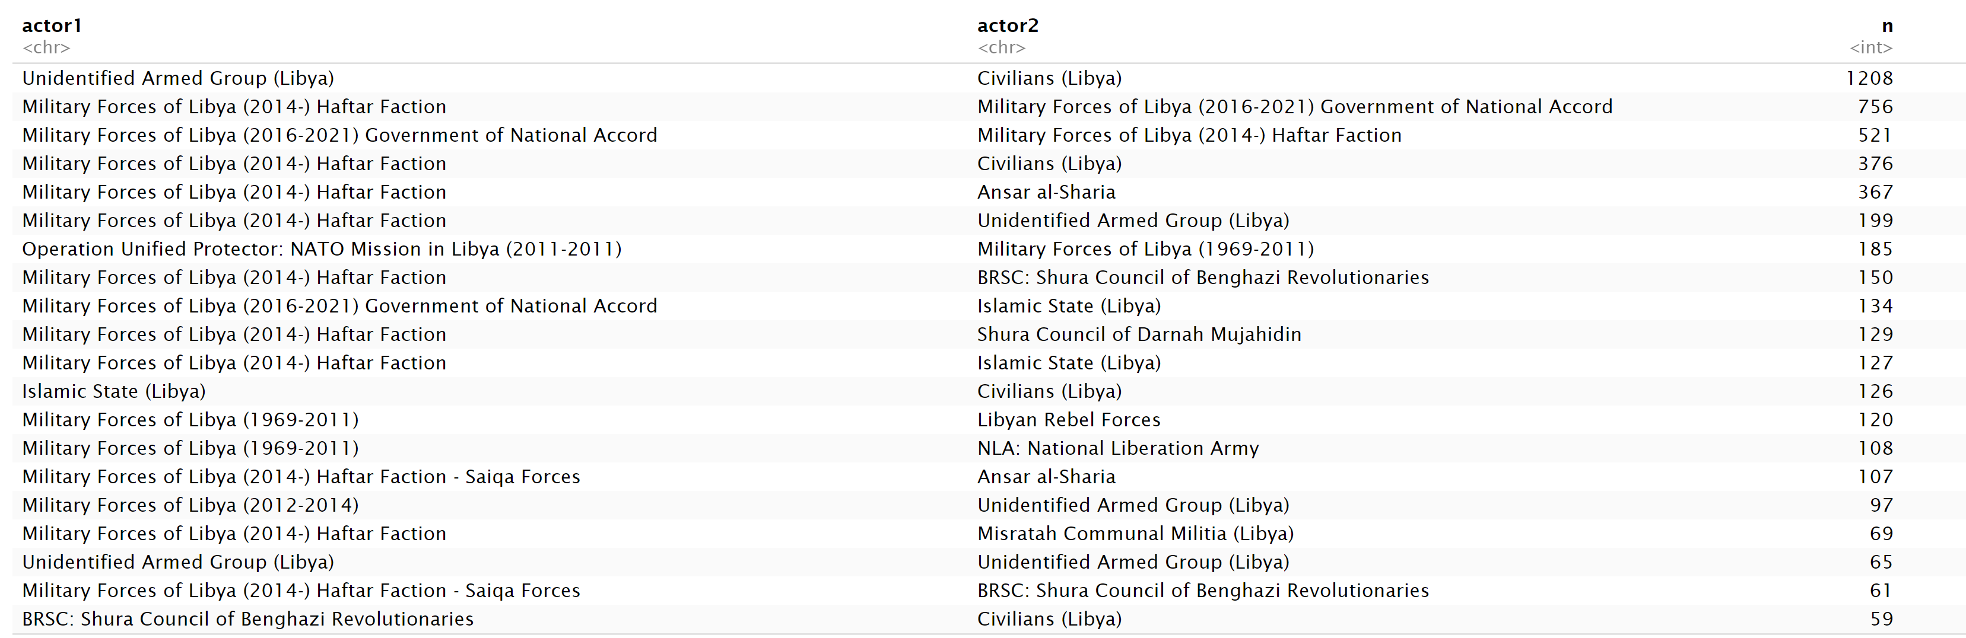

The dominant actor in conflict related events since 2014 is the rebel Haftar Faction of the Military Forces of Libya. Events attributed to the Haftar Faction have primarily involved conflict with the Government of National Accord, while also engaging with Islamist Militias as Ansar al-Sharia, BRSC: Shura Council of Benghazi Revolutionaries, Islamic State (Libya), and the Shura Council of Darnah Mujahidin.

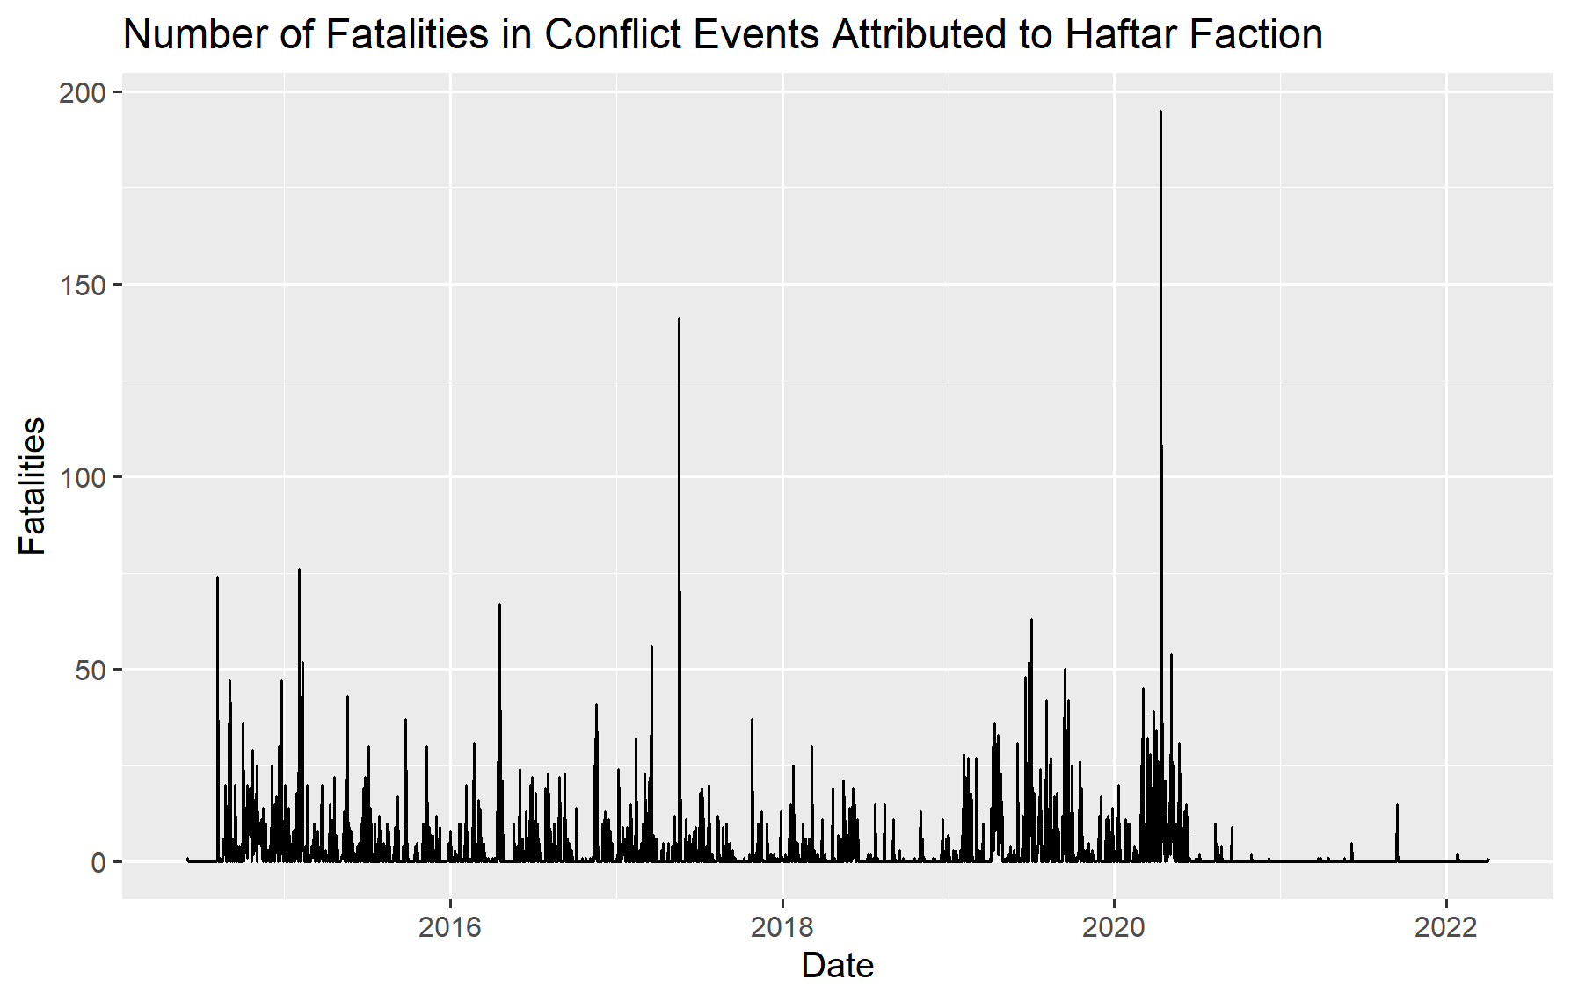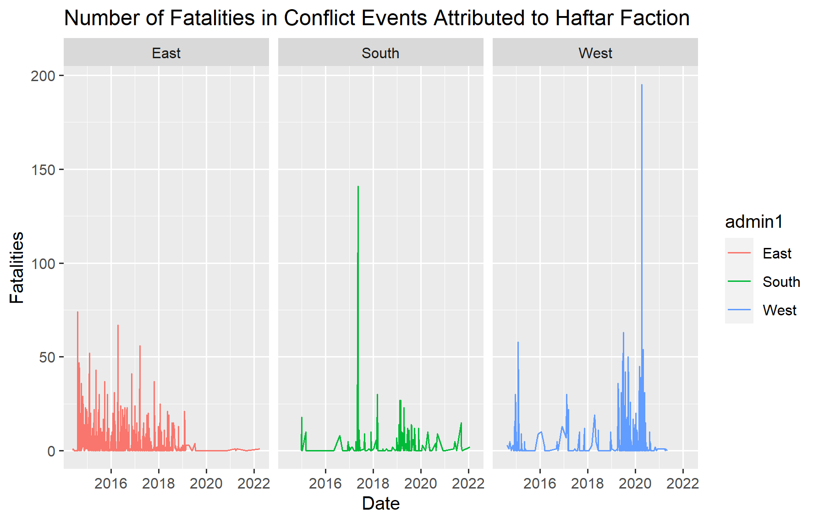

The graph above on the right displays the total number of fatalities in conflict events attributed to the Haftar Faction at the provincial level. Notably, the Haftar Faction is the only actor with a presence across the East, South and West provinces. It also suggests how the Haftar Faction has engaged in conflict across time: fatalities were initially concentrated in the East province starting in 2014 and slowly dissipated through the next five years. While fatalities in conflict events attributed to the group occurred with regular frequency in the South and West provinces, it significantly intensified in the West at the end of 2019 and start of 2020 before the ceasefire agreement and prior negotiations took place.

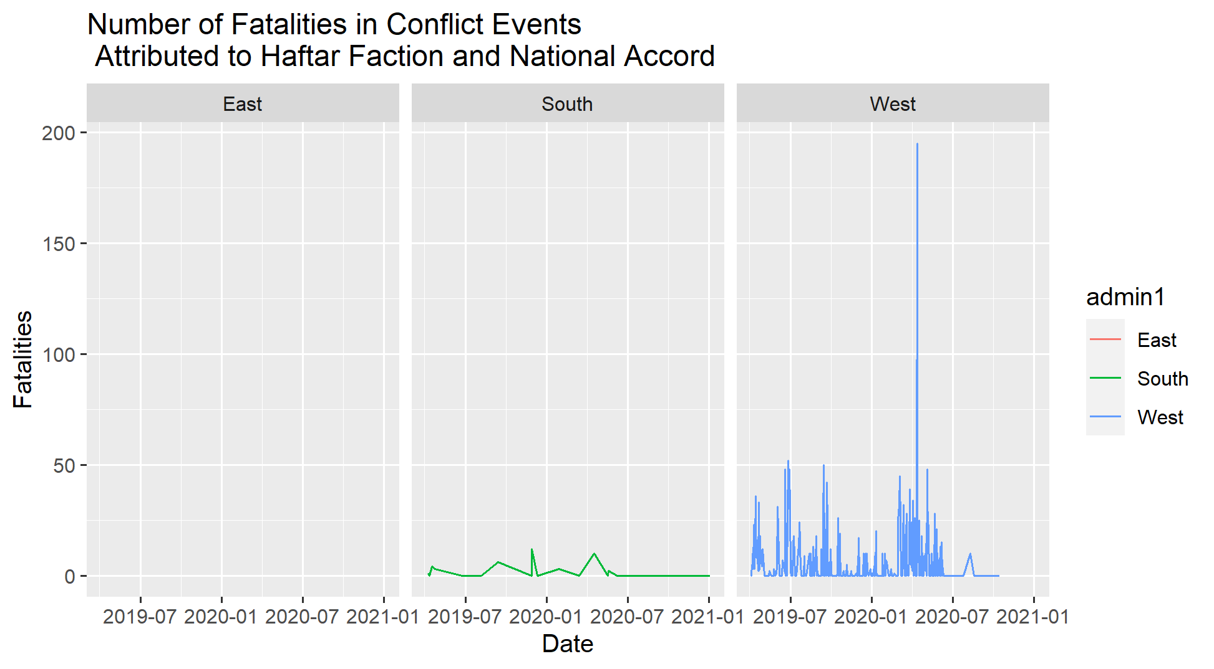 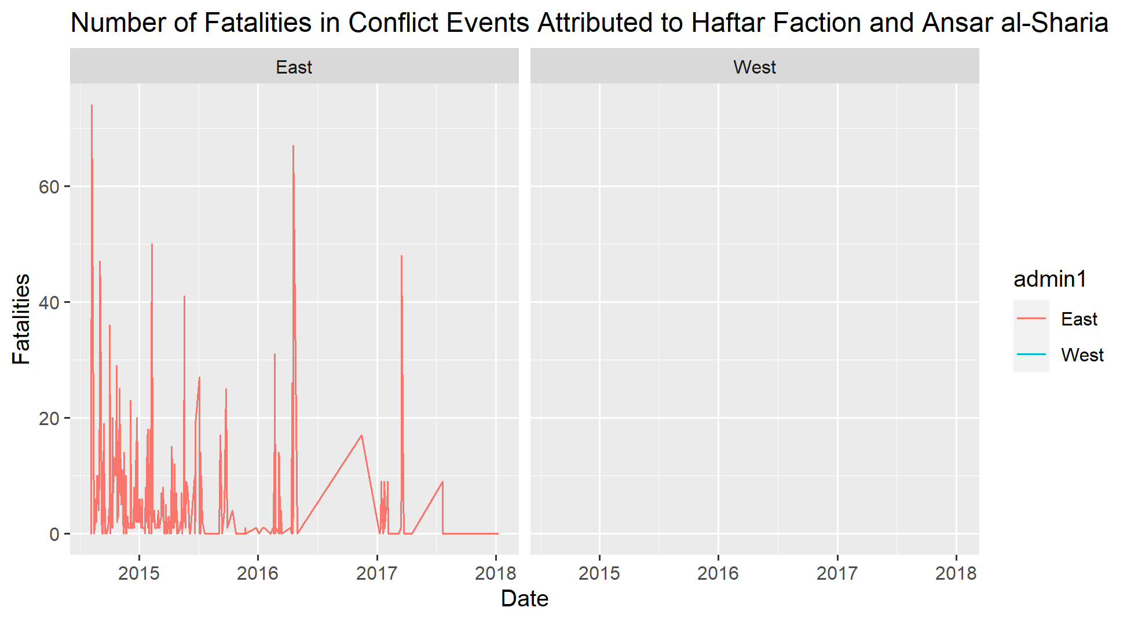

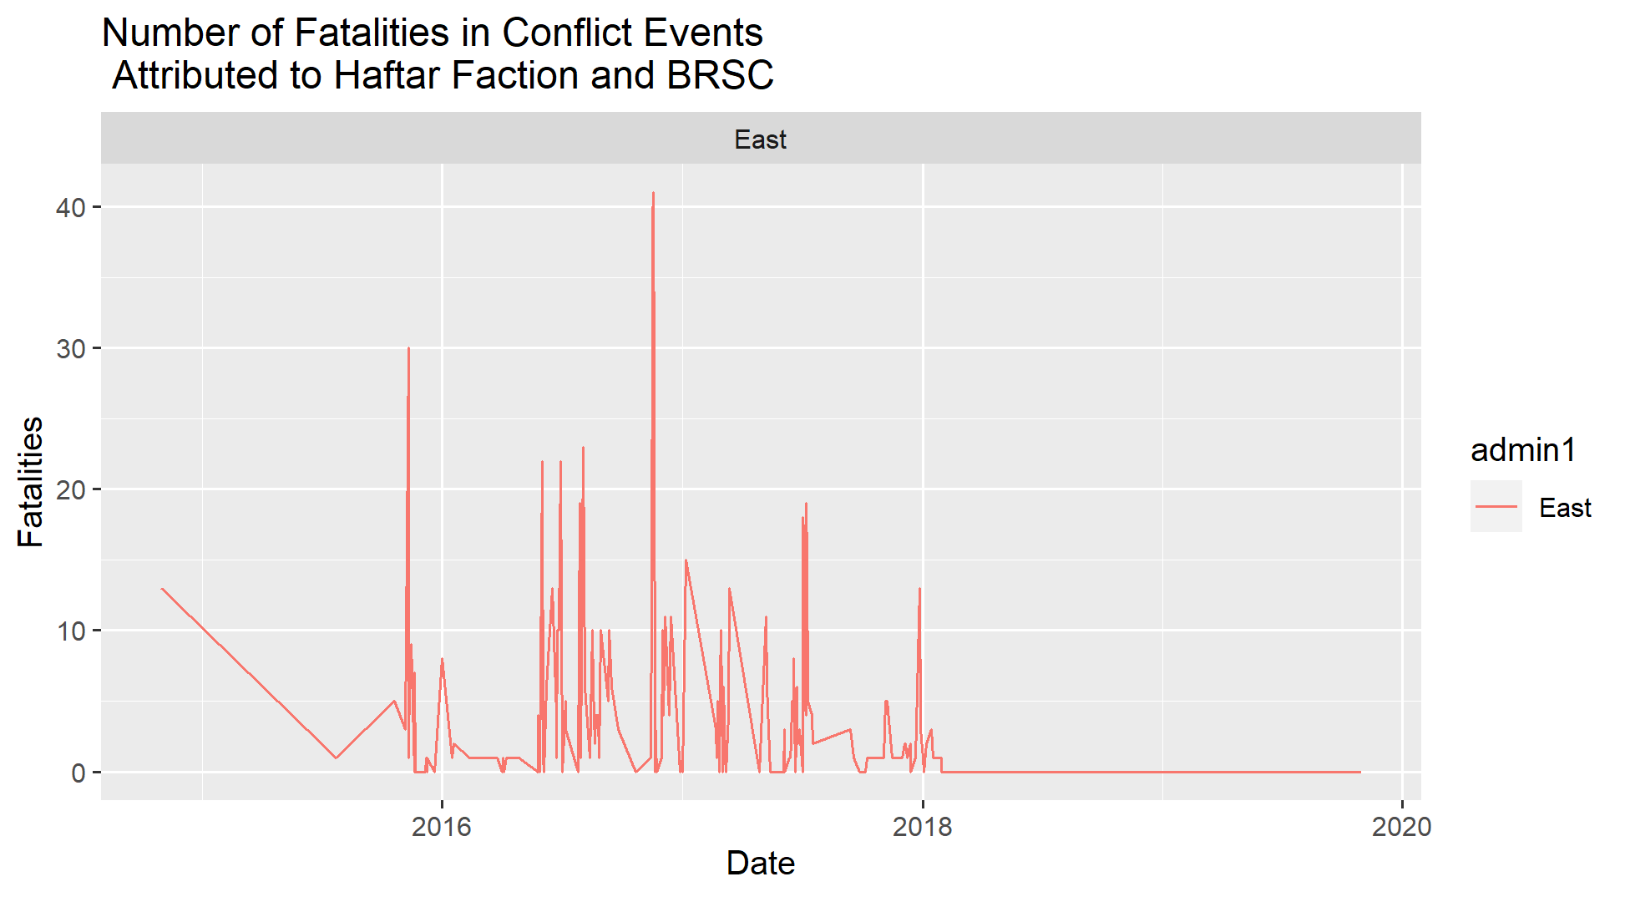 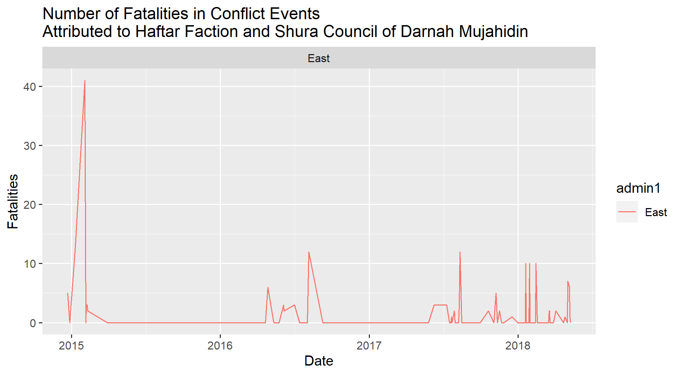

The graphs above highlight the regional fighting between the Haftar Faction and its main adversaries. What’s particularly noteworthy is the concentration of conflict with the Government of National Accord in the West region starting in 2019. Prior to this, the Haftar Faction was principally engaged in conflict with Islamist militias in the East province, such as Ansar al-Sharia, BRSC, and the Shura Council of Darnah Muujahidin. In terms of conflict with these latter groups, it is noteworthy that they have been significantly reduced to the point of inexistence since 2018.

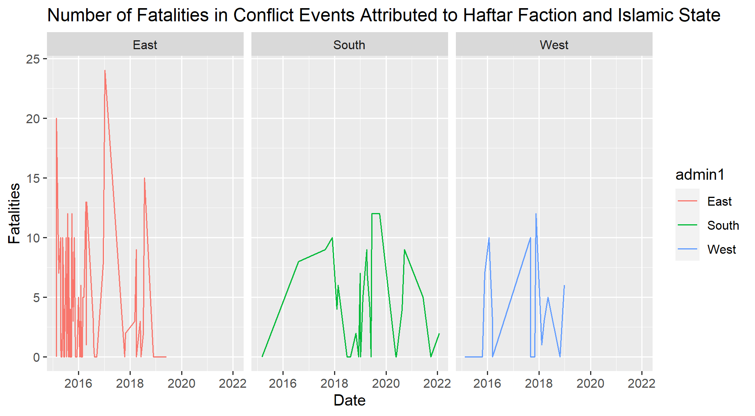

The exception to this is the Haftar Factions fighting with the Islamic State, as the graph shows above, Conflict between these two actors has had a national presence and included violent events in all three provinces. While these events between the two actors have completely stopped in the East and West since 2019, fatalities continue to occur in violent events in the South province.

**Predicting the Presence of the Haftar Faction in 2022**

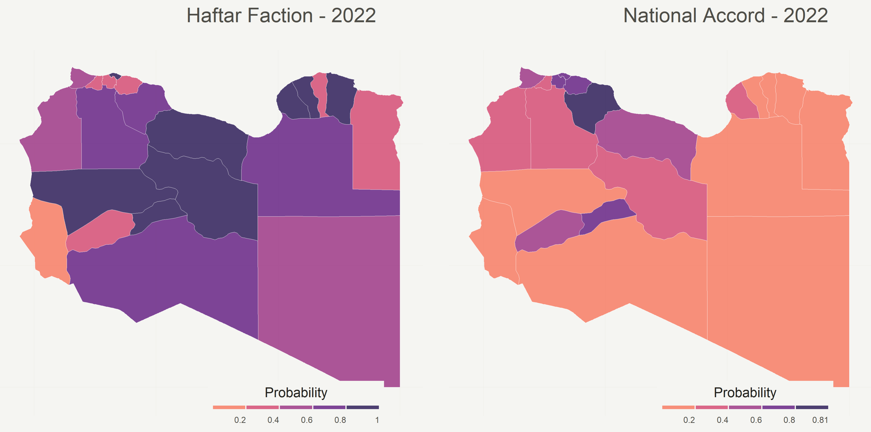

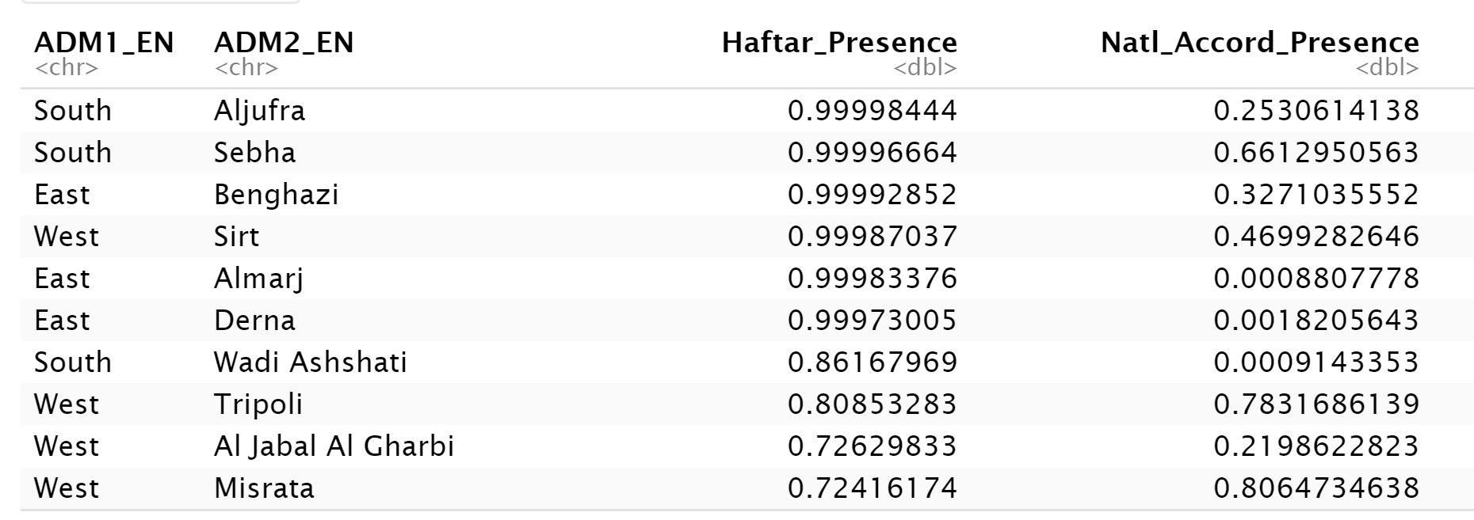

The output above shows on the one hand the likelihood of the Haftar Faction being involved in a violent event in the next year, and the same for the Government of National Accord. As the data on past events suggests, the Haftar Faction is more notably spread out throughout all geographies, while the Government of National Accord is more regionally concentrated in the West. It is important to note that these outputs were modelled separately: the likelihood of a violent event involving both actors is low in all regions for 2022.

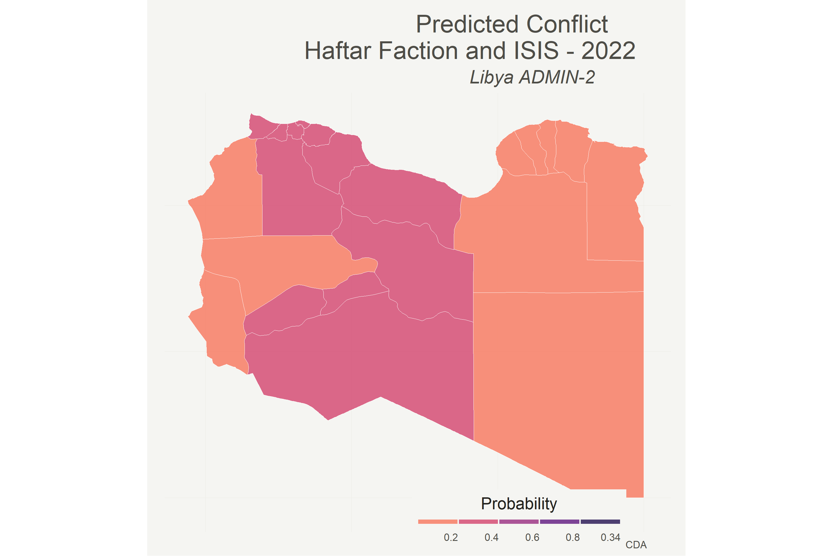

The predictive model assigns a higher likelihood of conflict between the Islamic State and Haftar Faction in the muhafazahs of the South provinces, which is where the majority of conflict has most recently occurred between these two actors. There

